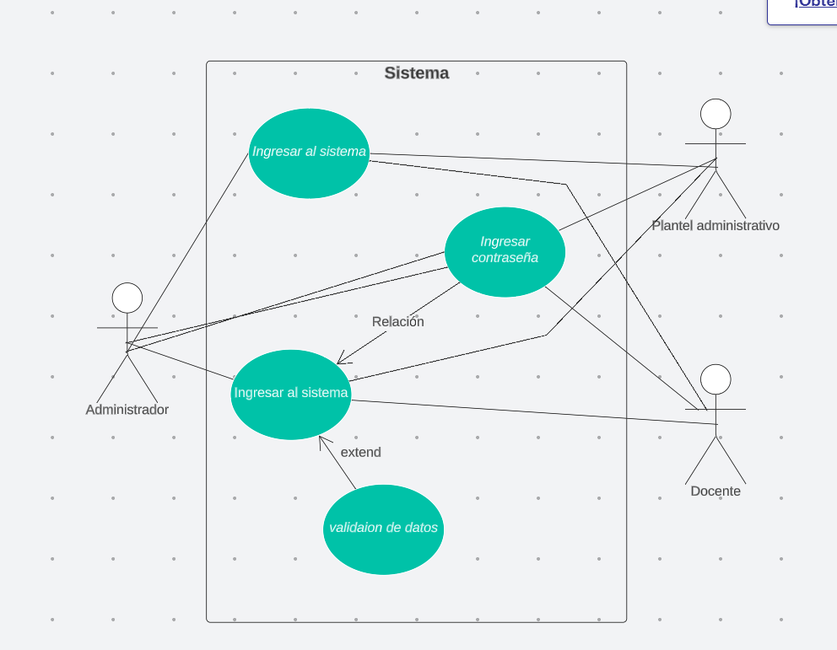

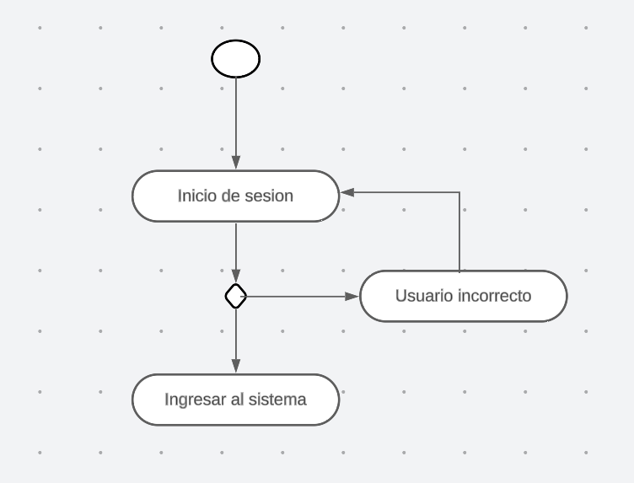

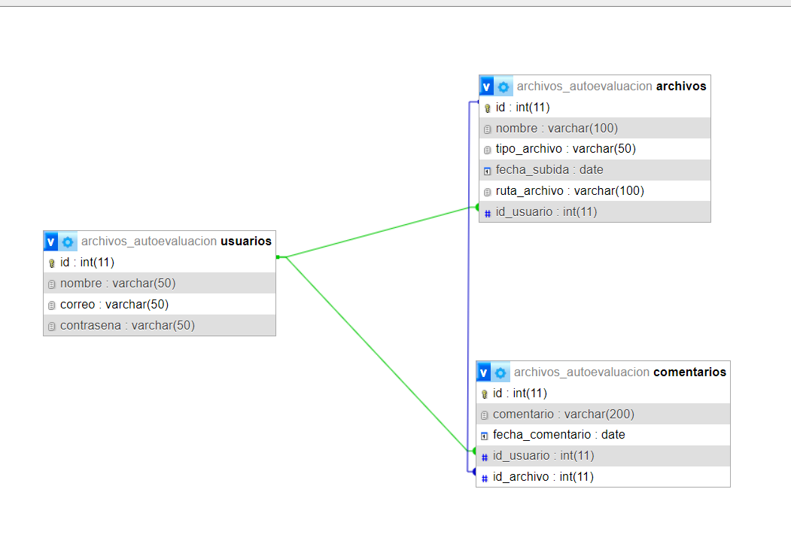

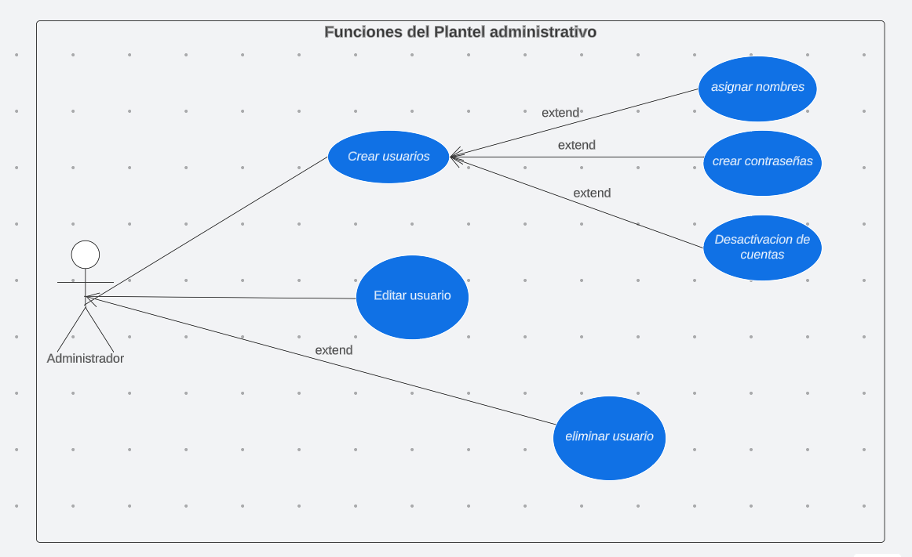

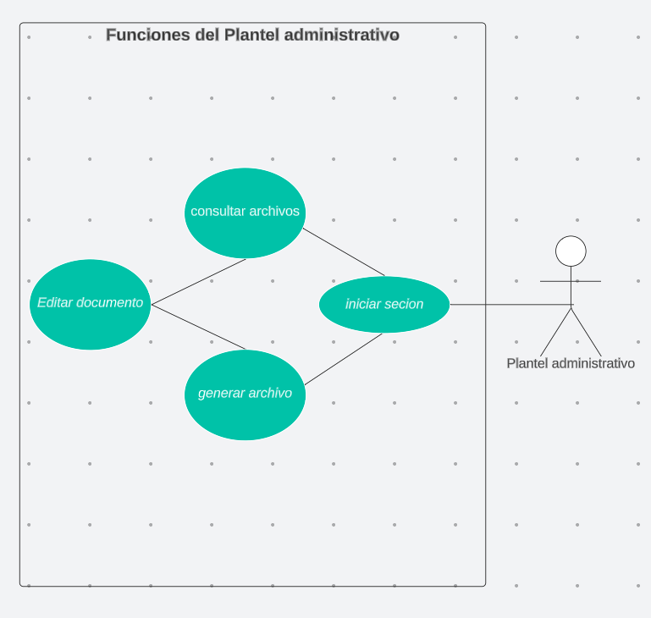

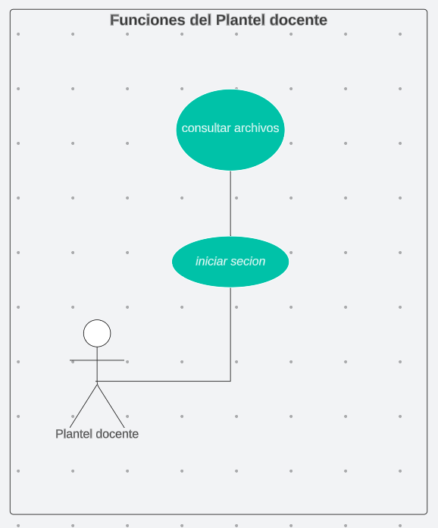

|  |  |  |
| --- | --- | --- |
| USUARIO | | |
| -id  -nombre  -apellido  -correo  -contraseña | Int    -Varchar(30)  -Varchar(30)  -Varchar(30)  -Varchar(30) |

|  |  |  |
| --- | --- | --- |
| DOCENTES | | |
| -id  -usuario id (int)  -especialidad  (varchar) | -Int  -Int  -varchar |

|  |  |  |
| --- | --- | --- |
| CARRERAS TÉCNICAS | | |
| -id  -nombre | -Int  -Varchar(30) |

|  |  |  |
| --- | --- | --- |
| AUTOEVALUACIÓN | | |
| -id  -carrera  -fecha  -observaciones | -Int  -Int  -Varchar(15)  -Varchar(100) |

|  |  |  |
| --- | --- | --- |
| Archivos | | |
| -id  -autoaval_id  -nombre  -codigo | -int  -int  -varchar(30)  -int |